Performance analysis of applying load balancing
strategies on different SDN environments
Mohamed I. Hamed¹, Basem M. ElHalawany², Mostafa M. Fouda³, and Adly S. Tag Eldien⁴.
^{1,2,3,4} Department of Electrical Engineering, Faculty of Engineering at Shoubra, Benha University, Cairo, Egypt.
E-mails: {m.ibrahim¹, basem.mamdoh², mfouda³, adlytag⁴}@feng.bu.edu.eg
Abstractـــ Software-Defined Network (SDN) is considered a breakthrough to the global network. It plays an important role in performance improvement and network optimization. SDN is a new mechanism for managing and designing networks rather than the current traditional network system which does not afford more services and higher data rates; therefore, we analyze the effect of applying load balancing techniques and its importance in different SDN environments. In this paper, we propose a dynamic server load balancing technique in SDN architecture. Hence, we implement a server Connection-based load balancing technique and evaluate its performance with a static Round-robin and Random-based in both mininet emulation environment and Raspberry Pi OpenFlow-enabled switch using Ryu OpenFlow controller. The performance of the proposed algorithm is compared with Round-robin and random distribution of clients' requests. The results show that the proposed technique achieves more reliability and higher resource utilization than the Round-robin and Random-based load balancing strategies. In addition, the proposed scheme exhibits more scalability and low-cost characteristics.
Key words: Software defined-network, Ryu controller, Load balancing, OpenFlow, Raspberry Pi.
Introduction
In a traditional switch, packet forwarding which can be described as the “data plane” and high-level routing (the control plane) occur on the same device. Some of the drawbacks of the traditional networks are that the physical network devices such as switches, routers, and load balancers are vendor specific. Some of these devices are not compatible with the each other [1]; furthermore, it is not allowed to change their functionality. SDN solves most of the traditional network issues and limitations. SDN is a new technology which decouples the control plane from data plane based on virtualization concept. The data plane is still implemented in the switch itself but the control plane is implemented in software and a separate SDN controller makes the high-level routing decisions [2]. The switch and controller communicate with each other by means of the OpenFlow protocol [3]. Data plane is responsible for the processing and delivery of packets based on the state of the routers and endpoints (e.g., Internet Protocol (IP), Transmission Control Protocol (TCP), Ethernet, etc.), while the control plane determines how and where the packets are forwarded based on the state of the network devices. As a result, network’s intelligence and state are logically centralized. SDN aims to make the network devices to be more software-based instead of hardware-based to improve the efficiency of the traditional network. SDN has a centralized controller which controls the traffic through the network. The most commonly used open-source SDN controllers are POX [4], Ryu [5], Trema [6], and OpenDayLight (ODL) [7]. In literature, Raspberry Pi is often used as an OpenFlow switch testbed because of its affordable price (only a few dollars) [8] while the other OpenFlow switches cost thousands of dollars [9]. In SDN, it is easy to program and adjust network rules and policies to manage network flows according to network requirements [10]. The SDN structure comprises of three layers as shown in Figure 1, which can be described as follows.
- Application layer: It is a layer at which applications and programs are installed that provides services to the infrastructure layer such as load balancing, firewall, and network monitoring.
- Control layer: It contains a centralized controller to control the traffic flows through the network and uses OpenFlow protocol to communicate with the infrastructure layer to monitor the overall view of the entire network.
- Infrastructure layer: It consists of both physical and virtual network devices such as switches, routers, and access points.
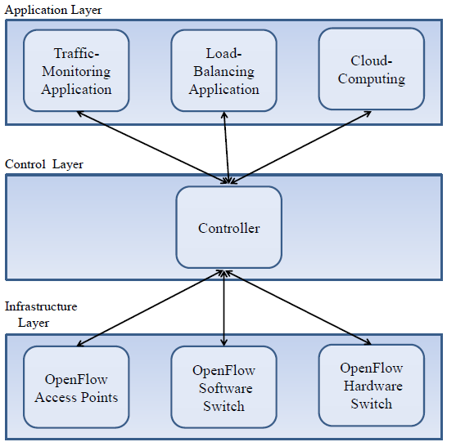
Figure 1. Three layers of SDN structure.

